Experiment 35:
Aim:
35.Write a Python program to draw a scatter plot comparing two subject marks.
Python code:
import matplotlib.pyplot as plt

# Data
math_marks = [88, 92, 80, 89, 100, 80, 60, 100, 80, 34]
science_marks = [35, 79, 79, 48, 100, 88, 32, 45, 20, 30]
marks_range = [0, 20, 40, 60, 80, 100]

# Create scatter plot
plt.scatter(math_marks, science_marks)

# Add labels and title
plt.title('Scatter Plot: Math Marks vs Science Marks')
plt.xlabel('Math Marks')
plt.ylabel('Science Marks')
plt.xticks(marks_range)
plt.yticks(marks_range)

plt.show()

Output:
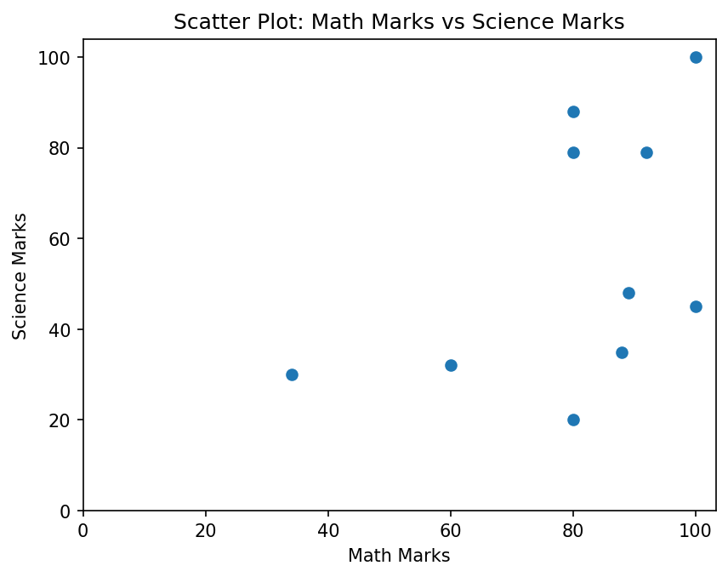
Experiment 36:
Aim:
36.Write a Python program to draw a scatter plot for three different groups comparing weights and heights.
Python code:
import matplotlib.pyplot as plt
import numpy as np

# Data
group1_weight = np.random.normal(60, 5, 20)
group1_height = np.random.normal(155, 4, 20)

group2_weight = np.random.normal(70, 6, 20)
group2_height = np.random.normal(165, 5, 20)

group3_weight = np.random.normal(80, 7, 20)
group3_height = np.random.normal(175, 6, 20)

# Create scatter plot for three groups
plt.scatter(group1_weight, group1_height, color='r', label='Group 1')
plt.scatter(group2_weight, group2_height, color='g', label='Group 2')
plt.scatter(group3_weight, group3_height, color='b', label='Group 3')

# Add labels and title
plt.title('Scatter Plot: Weights vs Heights for Three Groups')
plt.xlabel('Weight (kg)')
plt.ylabel('Height (cm)')
plt.legend()

plt.show()

Output:
